Nature of Enterprise- Group 30 Campus Companion App- Design Report
  - Names: Bintu Sankoh (A00042301), Kishaylin Reddy(A00021351), Matteo, Valentini Snijders(A00035719), Hannah Rossoni Pirola Dias(A00027340) and Shona Chanda(A00038833)

Table Of Contents:
Project Overview & Problem Statement
Target Users/ User Needs
System Design Layout
Architecture Overview
Data Design
Usability and UI Design
Accessibility Plan
Privacy, Security and Compliance
Deployment Plan
Appendix

Project Overview & Problem Statement
University students face increasing challenges in managing their academic and social responsibilities. Essential information is often scattered across different platforms, and communication channels can interfere with students' ability to navigate both physical and digital aspects of campus life. This fragmentation leads to unnecessary stress. New students struggle with orientation, finding buildings, understanding campus culture, and forming social connections. Returning students face heavier academic loads, extracurricular commitments, and personal responsibilities. Without a centralized, user-friendly tool, students often feel disorganized, which can negatively impact wellbeing and academic success.

The Campus Companion App aims to address these issues by providing a modern digital platform that supports students as they navigate university life. Many campuses rely on disconnected systems such as learning portals, email announcements, event pages, maps, and service websites. This can overwhelm students and make essential information difficult to access quickly. The Campus Companion App integrates these resources into one seamless experience, offering personalized timetables, campus navigation, event discovery, academic reminders, service directories, and real-time updates. Its goal is to enhance student engagement, reduce delays in daily tasks, and help students manage their time, responsibilities, and wellbeing more effectively. Ultimately, the app aims to be a reliable, accessible companion that supports students from their first day on campus, helping them stay connected and confident in their university journey.

Target Users / User Needs
User Persona 1: Aisha Thompson
Aisha is an 18-year-old first-year Psychology student living in on-campus accommodation. She is curious, social, and eager to get involved but easily overwhelmed by disorganization. Having moved from another city, she quickly realizes how fragmented university systems are. She checks multiple websites for class information, digs through emails for event announcements, and often gets lost navigating campus buildings. She wants to feel confident and in control, but juggling information leaves her stressed.

Goals: Stay organized with classes, deadlines, and events; navigate campus confidently; build a social circle; access student services; discover opportunities early.
Issues: Scattered information, confusing maps, missed events, overwhelming orientation, difficulty accessing services, feeling disconnected.

Needs: Centralized timetable, real-time navigation, smart reminders, services directory, personalized dashboard, access to clubs.

User Persona 2: Daniel O'Reilly

Daniel is a 21-year-old third-year Computer Science student who commutes 45 minutes daily. He is practical, efficient, and highly tech comfortable. His schedule includes lectures, labs, part-time work, and group projects. Because he is rarely on campus outside class hours, he often feels disconnected and misses spontaneous opportunities.

Goals: Optimize commute, stay on top of assignments, receive real-time updates, manage workload.

Issues: Late room-change notifications, difficulty finding study spaces, feeling disconnected, overloaded inbox, scattered group coordination.

Needs: Real-time alerts, dynamic study-space map, personalized event feed, academic calendar integration, commute-friendly features.

System Design Layout

The system design illustrates how the app processes student input from login to personalized output, showing data flow between the interface, backend services, and university systems.
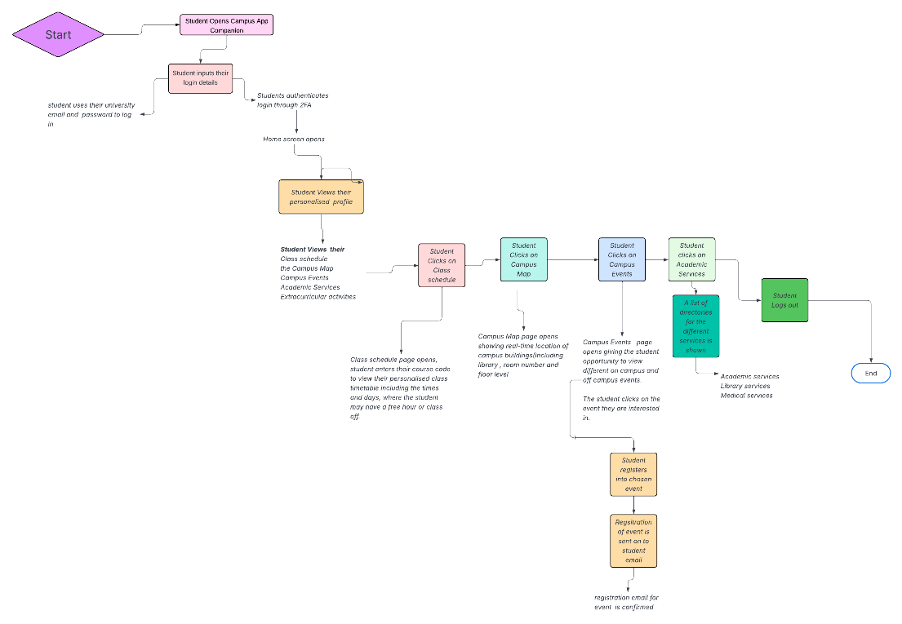

Architecture Overview
The Campus Companion App uses a modular, service-oriented architecture with four layers:
Client Layer, Application Layer, Integration Layer, and Data Layer.

Client Layer: Mobile interface prioritizing speed, accessibility, and personalization. Includes iOS/Android apps, web portal, and UI modules (Dashboard, Timetable, Map, Events, Notifications, Services Directory, Profile).

Application Layer: Core logic powering features such as User Profile Service, Schedule & Academic Service, Navigation Service, Events & Clubs Service, Notifications Service, and Search Service.

Integration Layer: Connects to university systems via API Gateway and connectors for LMS, SIS, security alerts, library systems, and authentication providers.

Data Layer: Stores structured and unstructured data using relational databases, NoSQL databases, and file storage.

Data Design

Entities include Student, Course, Course Session, Campus Location, Event, Campus Service, Notification, and User Preferences. Each entity contains attributes and relationships supporting timetables, navigation, events, and services.

Data Minimisation

To comply with GDPR, the app avoids collecting unnecessary data such as personal tracking, health records, mental health information, financial data, visa/immigration status, and biometric data.

Usability & UI Design
Navigation: Bottom navigation bar, consistent global navigation, deep linking, search bar, clear titles.
Layout: Reusable components, consistent spacing and typography, modular dashboard, visual hierarchy.

Feedback: Real-time confirmations, non-intrusive notifications, clear error messages, loading states, confirmation prompts.

Accessibility Plan

Headings: Logical hierarchy, navigation landmarks, screen-reader labels.
Labels: Descriptive labels, clear form fields, icons with text.
Keyboard Navigation: Full operability, high-contrast focus states, logical tab order, no traps.
Contrast: 4.5:1 ratio, no colour-only cues, adjustable text size.

Privacy, Security and Compliance
The Campus Companion App follows GDPR principles and university data governance standard.
On a Lawful Basis, the app follows the principles in the aspect of Contractual necessity: This means that providing schedules, navigations and notifications are a requirement for Student Services. As well as that Consent is another required aspect as an optional feature to create personalized recommendations and location-based navigation.
On the data Minimisation aspect, the app only needs to collect data that is relevant to students, this excludes, their health data, their location tracking and financial or biometric information.

On a Security Measure basis, it is Important that
- Data is encrypted and at rest, this means that it is not required to collect any data that is not required for the app.
- Regular penetration testing and vulnerability scanning is in place
- Secure authentication is through the university SSO
- And there is a strict API access Control and rate limiting

Deployment Plan
A highly-level deployment strategy ensures that reliability, scalability and smooth updates runs throughout the app.
One of the deployment plans was to host the mobile app through infrastructure. This includes
- Cloud-hosted environment using containerised services
- Auto-scaling groups to handle peak periods (e.g. Start of Semester)
- Load Balancers for distributing traffic across services.
Another deployment is the CI/CD Pipeline, this includes
- Automated testing
- Staged Deployment
- Canary releases for new features to reduce risk
Another deployment is the Pre- Launch Testing which includes
- Usability testing with diverse student groups
- Accessibility audits
- Performance testing for high-load scenarios
- Security penetration testing.
Another deployment is the App Distribution this where the app is distributed and published to the IOS APP Store and Google Play Store and it is university managed.

The Last Deployment stage is the Monitoring & Maintenance, this includes
- Real-time monitoring
- Analytical dashboards
- Regular Updates
- Incident response plan with clear escalation paths.

Wireframe for Home Screen of the Campus Companion App Homepage




